OFFICIAL TEAM & TRUSTEES
The Official Team is responsible for the fiscal policy of the church, assist the pastor in the fulfillment of the total church program, hire and terminate employees of the church (pastor excluded); shall determine the use of the church and fellowship/educational facilities for extra religious activities.
The Trustee Board is responsible for all property belonging to the church in taking the necessary measures for its protection, management.
Includes the Pastor, all deacons and the members listed below. CLICK HERE TO VIEW THE PASTOR. CLICK HERE TO VIEW THE DEACONS.

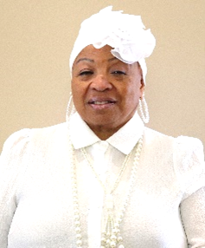

Carrie Jones
Member of Mt. Moriah since her childhood, member of the Deaconess Board for more than 5 years, member of the Official Team. Former member of the Music Ministry and Missionary Ministry.
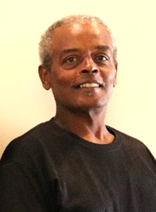

Derek Strong
Member for over 10 years, Member of Official Team, Lawn Keeper, Audio/Video Ministry.
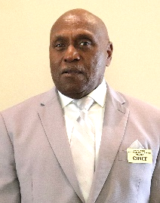

Richard Washington
President Usher Ministry; member of the Official Team; driver for the Transportation Ministry.
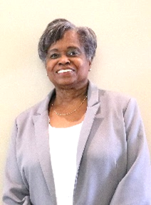

Brenda Stokes
Member over 40 years, member of Usher Ministry, Women’s Ministry, Culinary Ministry Head and Member of Official Team
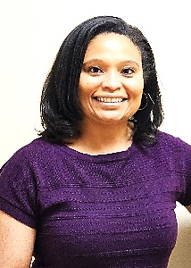

Tonya Gill
Head of the Youth Department
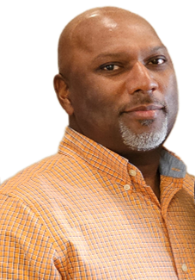

Elbert Speers
Audio/Video Tech, Photographer, member of Official Board
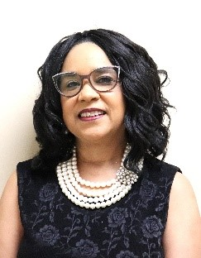

Marsha Roundtree
Church Administrative Assistant, Member of Women’s Ministry and Official Board


Bessie Newbern
Member over 20 years, Member of Official team, Former head of Decorations Ministry

